
Application for: Scale A Positions 2026
Dear Applicant
Thank you for expressing an interest in a position at Seatoun School. We have the following positions available.

We will most likely be looking for teachers for the following areas of the school:
Year 1, Year 3 and 4, Year 7 and 8

We have:
- One fixed-term scale, A teacher position. This could be in any area of our school. Indicate in the application form what area of the school you are interested in.
- Two permanent Scale A Positions. These could be in any area of our school. Indicate in the application form what area/s of the school you are interested in.

We have a collaborative, supportive, and reflective team that develops programmes that deliver outstanding education. We are focused on helping learners be the best they can be.
Seatoun School truly is a remarkable and rewarding place to teach and we look forward to your application.

The following is included in this document:

- Information about our School | - Teacher Role Description
- Criteria for appointment | - Application for Appointment
Additional information about our school can be obtained from the school website www.seatoun.school.nz.

The 2024 – 2025 Strategic Plan can be found on the school’s website.
Check out this video to get a feel for our school and see what we are about. We welcome visits so you can see for yourself what makes our school special.
Please complete the attached application and include a cover letter and CV.

The completed application for appointment is to be emailed to: sarah.gerondis@seatoun.school.nz

Timeline
14 August Position live and loaded on Gazette and our website
15 September Applications close at 9 am
22 Sept - 3 October Shortlisting of applicants
6-10 October Interviewing
January, 2026 Commencement of employment

Ngā mihi
John Western
Principal

Information about our School
___________________________________________________________________________________________________________________________________

Vision Statement
To be the best we can be.

Educational Approach
We aim to create a cooperative teaching and learning environment that is relevant, purposeful and challenging. We believe students need support to take risks and become independent learners.
We strongly emphasise the core areas of literacy and numeracy, but also recognise and value the importance of all the essential learning areas and skills.
We are an Apple Distinguished School and use technology when it adds value in creative, engaging and enhancing ways.
We encourage and recognise effort, progress and achievement and value creativity, innovation and fun.

Guiding Principles
Learning is at the core. We believe that everyone is capable of learning.
Student Agency. We encourage our students to take ownership of their learning and do their best at all times. Students know what they are learning, how they are doing and what their next learning steps are.
Teacher Effectiveness. Teachers continuously inquire into their practice to ensure they and each learner can be the best they can be.
High-functioning Teams. We strive to have high-functioning, collaborative, and supportive teams where we can achieve more because of the collective wisdom and knowledge of team members. We want teams to be enjoyable places to work and learn. We come to work with the intent to try our best and support everyone around us, staff and students, to be the best they can be.
Technology is an enabler. Technology is an essential tool within our professional practice as it supports learning. Teacher expertise and knowledge is expected. Personal development will be provided.

Shared Values
Manaakitanga
We show respect, support and kindness to each other.
Aroha mai, aroha atu- Love others and love will return to you.
Perseverance
We believe in ourselves and keep trying even when it gets hard.
Whāia te iti kahurangi- Aim high to achieve your goals.
Responsibility
We each play our part in looking after our school and our environment.
He rau ringa e oti ai- Many hands make light work.
Akoranga
We aim high and strive for success by learning together and from each other.
Whaowhia te kete mātauranga- Fill the basket of knowledge.

School Description

Seatoun School is a full primary school situated in Seatoun. The end-of-year roll will be around 410 students from around 29 ethnicities.

We have 17 classrooms. Our School is broken into teaching teams consisting of; three Year 0 or Year 1 classes, two Year 2 classes, four year 3 / 4 classes, four year 5 / 6 classes and four year 7 / 8 classes. In addition, we have a number of part-time specialist teachers delivering a wide variety of curriculum areas who run enrichment extension/support programmes as well as classroom release. We also have a considerable amount of Learning Assistant support targeted to both specific students and general student assistance.

We run a very flat management structure. We have two Associate Principals. One is responsible for years 1-4 and one for years 5-8. We have a Team Leader for our Year 3&4 team and one for our Year 7&8 Team. With the Principal, we are the Senior Leadership Team (SLT). All SLT are released each Friday. Our best teachers should be teaching and leading the learning for their teams and areas of the school.

We have exceptional physical resources and our classrooms are very well equipped.

Our teachers provide opportunities for personalised learning approaches that lift achievement levels and enable the students to understand their strengths and weaknesses using rich data. All our students receive a well-rounded, balanced, and high-quality education. Our staff are very talented and high-performing professionals who enjoy a collaborative team approach, and collegiality is evident in our school.

We are an Apple Distinguished School. The successful applicant will ideally be familiar with the Apple ecosystem or willing to learn quickly. We are very selective and mindful of our use of technology. We base our practice on the SAMR model.

We value professional development and look after each other.

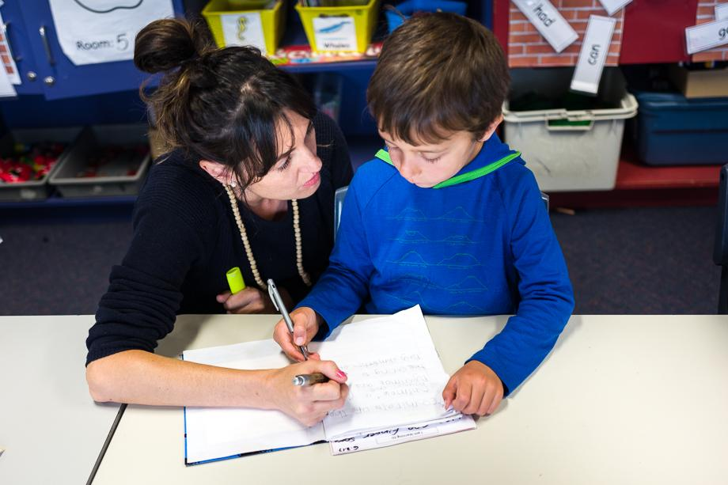 |  | 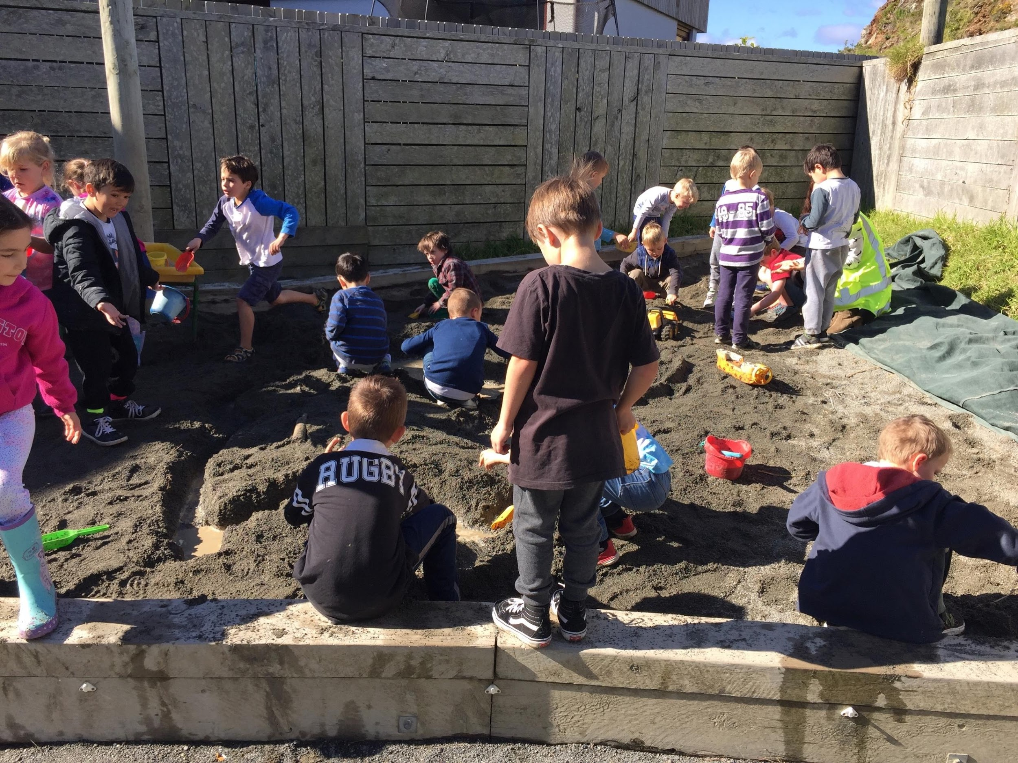

Criteria for Appointment and Person Characteristics
_____________________________________________________________________________________________________________________________________________

The Scale A teacher we appoint will be:

- An enthusiastic and innovative classroom teacher.
- A team player with a sense of humour.
- Experienced or interested in personalised learning and teaching through the inquiry process.
- A collaborative and highly motivating teacher.
- Able to integrate their teaching practice throughout curriculum areas.
- Able to use data to improve teaching practice and student outcomes.
- Committed to the school’s positive culture.
- Involved in developing themselves as a professional through professional learning and development opportunities.
- Committed to giving effect to Te Tiriti o Waitangi.
- Able to develop positive relationships with students and colleagues.

Teacher Role Description
Responsible to: Principal

Person Attributes:
- Uphold the school’s approach to education, vision, core beliefs and shared values
- Adhere to the school’s Code of Conduct (Teaching Council Code)
- Implement the NZ and School Curriculum
- Follow the planning and assessment expectations of the school
- Meet the Practising Teacher Criteria and Professional Standards

Primary Objectives:
- Model and promote positive and constructive relationships with staff, students and the community
- Actively engage in professional, open to learning conversations
- Value team-work and collaborate with others
- Share knowledge, skills and resources
- Explore, recognise and celebrate Māori identity, language and culture, including making good use of local expertise and the local context
- Apply the ‘teaching as inquiry’ process and strategies with a view to improving practice and student outcomes
- Use classroom practices and implement programmes that engage all learners, accelerate learning of all students so that they experience success
- Use a range of strategies to support students to have a voice in co-constructing what and how they learn.

Key Tasks | Expected Results
1. Teaching and Learning | - Maintain appropriate planning and assessment records  - Maintain a safe, well-organised, student-focussed learning environment  - Continually adapt and modify activities, resources and technologies in order to scaffold students’ learning  - Reflect on classroom practice in an on-going way  - Change and adapt current practice in response to students’ needs and new evidence and research  - Create a classroom environment where students can take risks with their learning and see mistakes as learning opportunities  - Acknowledge, respect and encourage student voice, their perspectives and values
2.Professional learning and Development | - Undertake professional support and guidance  - Attend all PLD opportunities offered  - Be open to learning  - Commit to making on-going improvements to practice

Application for Appointment
Important Notes for Applicants

Thank you for applying for a position within our school. Please ensure you refer to and reflect on the role description, job description and person specifications before completing this application.

- Please fully complete this form personally. Read it through first then answer all questions and make sure you sign and date where indicated on the last page (digital is fine).
- Attach a curriculum vitae (CV) containing any additional information. If you include written references, please note that we may contact the writers of the references.
- If successful in your application, you will be required to provide originals as proof of qualifications.
- If you are selected for an interview, you may bring whanau/support people at your own expense. Please advise if this is your intention.
- Failure to complete this application and answer all questions truthfully may result in any offer of employment being withdrawn or appointment being terminated if any information is later found to be false.

In terms of a criminal conviction, the criminal records (Clean Slate) Act 2004 provides certain convictions do not have to be disclosed providing:
- you have not committed any offences within 7 (consecutive) years of being sentenced for the offence and
- you did not serve a custodial sentence at any time (this would exclude serious offences such as murder, manslaughter, rape and causing serious bodily harm) and
- the offence was not a specified offence (specified defences are in the main sexual in nature) and
- you have paid any fines or costs.

Custodial sentences include ascendance of preventative detention and corrective training. Non-custodial sentences include fines, reparation orders, community-based sentences and suspended sentences. Please note that you are not obliged to disclose convictions if you are an eligible individual but can do so if you wish. If you are uncertain as to whether you are eligible contact the Ministry of Justice.

Under the Vulnerable Children Act 2014, core workers in schools will not be covered by the Clean Slate.

All serious sexual violent offences against children will be included in the police vetting results. The Act will make it unlawful to employ people with convictions for these offences, unless they have an exemption.

This application form and supporting documents, will be held by the school. You may access it in accordance with the provisions of the Privacy Act 1993. If you have any queries please contact the Principal, John Western.

Proof of Identity
Your appointment will be conditional on you providing proof of identity. You will need to provide two types of identification (one photo ID e.g. passport, New Zealand drivers licence and the other a record ID e.g. birth certificate, bank statement, utility account).

Application Form

To: Appointments Committee (email completed application and CV to sarah.gerondis@seatoun.school.nz)

Position/s Applied For:

Scale A, Permanent
Scale A, Fixed Term Position - 2026

Personal Details
Full name: | Preferred title
If you are known by another name please state
Address

Year Level you would prefer to teach
Please indicate the year level/s you would be interested in teaching in. | - Year 1 / 2  - Year 3 / 4  - Year 5 / 6  - Year 7/ 8

Telephone (Home) |  | Telephone (Mobile)
Email
NZ Registration Status (highlight/circle one) | Full | Provisional | Subject to Confirmation
Registration Number |  | Expiry Date

Qualifications (only complete if not in CV)
Qualification Attained | Name of Institution | Date Awarded | Years undertaking Qual

Please tick the appropriate boxes: ✓ | Y | N
Are you a New Zealand citizen?
If not, do you have resident status, or
A current work permit?
Have you ever had a criminal conviction (convictions under the clean slate scheme excluded)?
If “Yes” please detail:
Please tick the appropriate boxes: ✓ | Y | N
Have you ever been convicted of a driving offence which resulted in temporary or permanent loss of license, or imprisonment? If “Yes” please detail below.

Are you awaiting sentencing or have charges pending? If yes, please state the nature of the conviction/cases pending below.

In addition to other information provided, are there any other factors that we should know to assess your suitability for appointment and your ability to do the job?

If “Yes’, please elaborate below.

Have you ever been subject of any concerns involving students safety?

If “Yes” please detail below.

Please tick the appropriate boxes: ✓ | Y | N
Have you had any injury or medical condition caused by a gradual process, disease or infection, such as occupational overuse syndrome, stress or repetitive strain injuries, which the task of this position may aggravate or contribute to?

If “Yes” please detail below.

Do you have a current New Zealand driver's licence? | Y | N

Employment History
Please list your work experience in your last five positions beginning with your most recent position held. If you were self-employed, give details. If you have had more than five positions in the last five years, please list them all. Attach additional sheets if necessary.

School | Position held | Reason for leaving | Period employed

Referees
Please provide the names of three people who could act as referees for you. At least one of these referees should be someone who has been your line manager or Principal you have reported to. If you have included written references from people other than those recorded below, please note that we may contact the writers of these references.
Name | Contact Details  (Organisation & Address) | Phone  (Mobile, work, home) | Relationship  (e.g. BOT Chair, Principal), including how long you have known the person

Authority to approach other referees | Y | N
I authorise the Board, or nominated representative, to approach persons other than the referees whose names I have supplied, to gather information related to my suitability for appointment to the position.
I authorise the Board, or nominated representative, permission to access any information held by the education council of Aotearoa New Zealand (EDUCANZ) or any other educational organisation, including information regarding matters under investigation, to gather information related to my suitability for the appointment to the position.

The position you have applied for requires specific knowledge, skills, attributes and personal characteristics. These are stated in the criteria for appointment and person characteristics section of this application pack. Please outline below how you meet these attributes and abilities. Even though you are attaching a CV, please fill this out in full.

Self assessment
Please complete the following sections. Either use this document or a separate one.

What empowers and inspires learners, and makes learning happen?
What excites you about joining the team at Seatoun School?
Any other information
Please use the following space to provide any additional information that you wish the Board to consider when reflecting on your application.
Signature and Date
I certify that:
- The information I have supplied in this application is true and correct.
- I confirm in terms of the Privacy Act 1993 that I have authorised access to referees.
- I understand that if I have supplied incorrect or misleading information, or have omitted any important information, I may be disqualified from appointment, or if appointed, may be liable to be dismissed.

Signature: |  | Date:
Please ensure this form is completed fully and included along with your personal curriculum vitae and covering letter in your application.

Add for Website / Gazette

Kaiako Several Positions

Full Time Permanent Positions and Fixed Term Position
Full Primary, U5 school.
Seatoun School is looking for passionate kaiako to join our team from the beginning of the 2026 academic year.
A unique opportunity awaits the successful candidates. We seek enthusiastic, energetic, creative, innovative classroom teachers to be part of our team. The successful candidates will;
- be collaborative educators who
  - Use an integrated teaching approach
  - love working in a fast-paced, progressive team environment that is very well-resourced
  - has a sound understanding of modern learning pedagogies and is able to deliver high-quality literacy and numeracy programmes
Please view the application pack and form for information on potential areas of the school that have vacancies.
Check out this video to get a feel for our school and see what we are about. We welcome visits so you can see for yourself what makes our school special.
Email application to:
sarah.gerondis@seatoun.school.nz
Timeline
Timeline
14 August Position live and loaded on Gazette and our website
15 September Applications close at 9 am
22 Sept - 3 October Shortlisting of applicants
6-10 October Interviewing

January, 2026 Commencement of employment

